**( Creating file on nodes)**

# vim /home/ec2-user/chef-repo/cookbooks/httpd/recipes/default.rb

file '/file1' do

content 'Hello world... I am file1 created by chef'

end

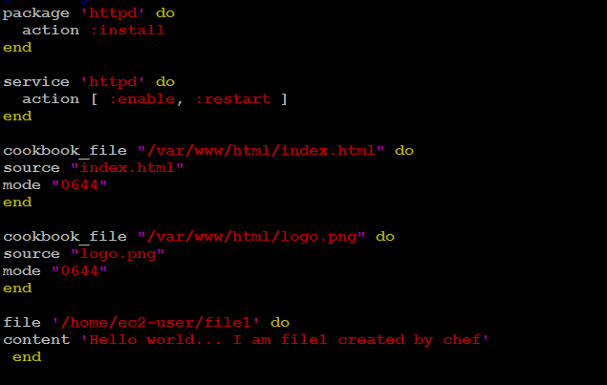

## **Step 2: Upload Cookbook to chef-server**

# knife cookbook upload httpd

## **Step 3 : run chef client on rhel node**

knife ssh "*:*" -x ec2-user --identity-file chef.pem "sudo chef-client"

## **Step 4: Login into rhel node from your workstation**

ssh -i "ibm-public-key.pem" [ec2-user@ec2-52-67-119-162.sa-east-1.compute.amazonaws.com](mailto:ec2-user@ec2-52-67-119-162.sa-east-1.compute.amazonaws.com)

cat file1

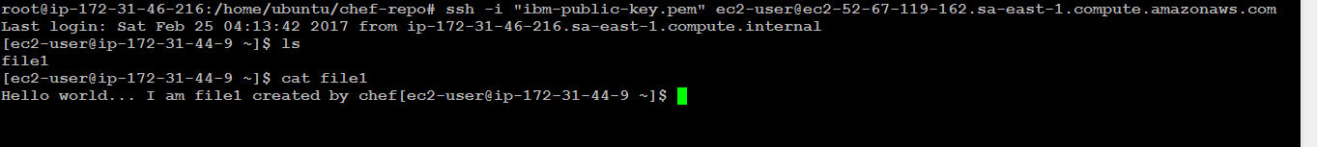

**Addon Optional( Deleting file on nodes)**

file '/home/ubuntu/file1' do

action :delete

end